

**FACULTY OF INFORMATICS**

**COURSEWORK COVERSHEET**

|  |  |  |  |
| --- | --- | --- | --- |
| **SUBJECT’S INFORMATION:** | | | |
| Subject: | CSCI361 Cryptography and Secure Applications | | |
| Session: | July 2019 | | |
| Programme / Section: | BCS (S1, D1) | | |
| Lecturer: | **Mohamad Faizal Alias** | | |
| Coursework Type  *(tick appropriate box)* | ❑ Individual Assignment | | |
| Coursework Title: | Assignment 4 | Coursework Percentage: | 10% |
| Hand-out Date: | Week 12 | Received By :  (signature) |  |
| Due Date: | Week 16 | Received Date : |  |
| **STUDENT’S INFORMATION:** | | | |
| Student’s Name & ID: | **TEH WIN SAM**  **J16025133** |  |  |
| Contact Number / Email: | **ME@TEHWINSAM.COM**  **0133696298** |  |  |
| **STUDENT’S DECLARATION** | | | |
| By signing this, I / We declare that:   1. This assignment meets all the requirements for the subject as detailed in the relevant Subject Outline, which I/ we have read. 2. It is my / our own work and I / we did not collaborate with or copy from others. 3. I / we have read and understand my responsibilities under the University of Wollongong’s policy on plagiarism. 4. I / we have not plagiarised from published work (including the internet). Where I have used the work from others, I / we have referenced it in the text and provided a reference list at the end of the assignment.   I am / we are aware that late submission without an authorised extension from the subject co-ordinator may incur a penalty. *(See your subject outline for further information).* | | | |
| Name & Signature: |  |  |  |

------------✂ -------------------✂ ------------------✂ -------------------✂ --------------------✂ ---------------------✂ --

|  |  |  |  |  |
| --- | --- | --- | --- | --- |
| Subject: | CSCI361 Cryptography and Secure Application | | Session: | July 2019 |
| Programme / Section: | BCS | | Lecturer: | **Mohamad Faizal Alias** |
| Coursework Type:  (Tick appropriate box) | ❑ Individual Assignment | | | |
| Coursework Title: | Assignment 4 | Coursework Percentage: | | 10% |
| Hand-out Date: | Week 12 | Received By:  (Signature) | |  |
| Due date: | Week 16 | Received Date: | |  |
| **STUDENT’S INFORMATION:** | | | | |
| Student’s Name & ID: |  |  | |  |
| Contact Number / Email: |  |  | |  |

**COURSEWORK SUBMISSION RECEIPT**

|  |  |  |  |
| --- | --- | --- | --- |
| **Assessment Criteria** | | **Total Marks** | **Given Marks** |
|  | Client-Server Execution | 10 |  |
|  | Client - Key Generation coding **RSA (PUa & PRa)** | 10 |  |
|  | Server Verify **PUa** with Hash of **PUa** – received from Client | 10 |  |
|  | Server IDEA Key Gen (**Ks**) & MD-5 Hash for **Ks + E(PUa, Ks)** | 20 |  |
|  | Client decrypt **D(PRa, Ks)** and Verify Hash of Ks | 10 |  |
|  | Encrypted data communication process – **3DES with CBC Mode** | 20 |  |
|  | Overall report & Presentation | 20 |  |
|  | | **100** |  |
|  | | **Penalty** |  |
| Marked by: _____________________ Date: ________ | | **Final Mark (10 %)** |  |
| **Lecturer’s Comments** | | | |
|  | | | |
| **Penalty for late submission:** | | | |
| 1 day – minus 20% of total mark awarded  2 days – minus 50% of total mark awarded  3 days – 0 mark for this piece of coursework | | | |

**University of Wollongong**

**CSCI361: Cryptography and Secure Applications**

**July 2019 Session**

**Individual Assignment 4 (10 %)**

**Tasks:**

* Extend and implement of the **RSA** PKC scheme in station-to-station communication
* Using Hashing for integrity of message, that is **MD-5**
* Produce simple Key Transport protocol
* **3DES** encryption with 2 Keys a.k.a. 3DES-EDE2
* Mode of Block Cipher is **CBC Mode**

**Specifications:**

The aim of this assignment is to create a program that allows two different stations to communicate by initiating the following protocols:

Some Guidelines before you start:

1. Those who planned to use VM or VirtualBox, make sure that you’ve installed VM/VirtualBox and configure the Network and set the configuration to use Bridge mode
2. After setting up VM/VirtualBox with Bridge mode only install your Linux or other OSes that you preferred.
3. Each time you test the server and the client program, the server need to open a port (port number). Any error during testing your OS might not release the port number and/or the port currently having buffer of previous data. This might lead to error on your second-time execution of your program. It is suggested that each time you execute server, change the port number and let the client program use the new port number opened.
4. Developed both server and client code in separate folders. This to ensure any local copy of reference file (if so exists) won’t give you a misleading error or/and success of the code execution.
5. Use any C++ sample of socket programming and execute them first to ensure that the sample is working on real network environment. It is NOT suggested to use WinSock since it might bound to restriction in Windows environment.
6. You can use two computers and connect them via Ethernet cable (CAT5 cable) directly to simulate a network.
7. You may be interested to venture into multithreading
8. Observed carefully the protocol given below:

Handshake Process:

|  |  |  |
| --- | --- | --- |
| https://www.wpclipart.com/computer/PCs/thin_client.png  Client Program | Preferable your program is proven to be running on the real network NOT only on Localhost with VMWare | https://www.wpclipart.com/computer/PCs/thin_client.png  Server Program |
|  |  | 1. Start a Host (server) – Initiate by entering the port no. for client to connect |
| 1. Execute client – enters the IP and Port number of the Server 2. Client program: starts with generating key pairs; PUA-Public Key and PRA-Private Key using **RSA** 3. PUA will be send over to the server, together with the Hash of PUA using **MD-5** for integrity checking. PRA is kept by Client for later Decryption. | PUa || H(PUa) || Flag to connect (optional) | 1. Upon receiving PUA and H(PUA), Verify them using **MD-5**. 2. Server generates a session key **Ks1** (**Key size of 8 Bytes)** for the purpose of two keys **3DES encryption** 3. Next, the Server prepares Ks = Ks1 + Ks2   Ks1 is the 8 bytes key while Ks2 is the **reverse of Ks1** |
|  | E(PUa, Ks1) || H(Ks1) || Flag for acknowledgement (optional) | 1. Server then sends over to Client, encrypted **Ks1** (**8 Bytes**) using PUA that is E(PUA, **Ks1**) and H(**Ks1**) |
| 1. Upon Receiving of E(PUA, **Ks1**) and H(**Ks1**); Client Decrypt the message using PRA , get to know **Ks1** (**3DES Key size 8 Bytes)**. 2. Then it verifies the integrity of **Ks1** by checking H(**Ks1**) – Hashing via **MD-5** |  |  |

**Note**:

* Prepare your program so that it will request the user to enter appropriate settings such as IP number and port number.
* Connection is using socket programming either using UDP or TCP.
* You may use all functionalities available in Crypto++ library
* Flags are optional depending on your technique to control the handshake process.
* IV for CBC mode can be hardcoded in both of your Client and Server code
* Reference: https://www.cryptopp.com/wiki/TripleDES

Data Communication Process:

|  |  |  |
| --- | --- | --- |
| https://www.wpclipart.com/computer/PCs/thin_client.png  Client Program |  | https://www.wpclipart.com/computer/PCs/thin_client.png  Server Program |
| 1. Upon completion of Handshake process above, Client is now use **Ks1** to generate **Ks2** by reversing **Ks1** to produce the complete 3DES Key (**Ks1+ Ks2 = Ks)** to encrypt its data communication 2. Client program: Encrypt the message **Mc** using **3DES** encryption with the agreed session **Ks1+ Ks2** (**3DES Key size**) 3. Message **Mc** enters **3DES** encryption using **CBC Mode** 4. Upon receiving message **Ms** from server, client can decrypt it using the session **Ks** 5. Communication continues until ‘**Quit’** signal initiated | E(Ks, M) || Flag – from Client  E(Ks, M)|| Flag – from Server | 1. Server then Decrypt the message **Mc** from client using **Ks1+ Ks2 = Ks** 2. Server program: Encrypt the message **Ms** using **3DES** encryption with the agreed session **Ks** (**3DES**) 3. Message **Ms** enters **3DES** encryption using **CBC Mode** 4. Communication continues until ‘**Quit’** signal initiated |

**Note**:

* The working of message sending and receiving works something like a chat program.
* All the above decisions and reusable library must be reported and reference accordingly
* Data communication process between A and B can be done either through VMware or a more appropriate approach is over the real network (you can use 2 computers for this purpose during presentation)
* Flags are optional – depending on how you control the data communication

**Reporting**

You are to include in your report all the following (but not bound to only these requirements):

* + - 1. Setting-up of the Stations involved simulation requirements etc.
      2. All cryptosystem and Hashing strategies implemented
      3. Discussion on the execution (steps) of your program
      4. program explanation (on all methods used), overall program structure, data input/output, analysis results
      5. Other requirements deem important

**Submission**

Your source code should be submitted together with the report.pdf file in one folder. ZIP the folder and named it <your-name-CSC361-Assign4>.zip and submit this ZIP file to Moodle Submission link provided. Remember to put your name and student number in all source codes (comments header).

Provide readme.txt file to guide me on your library used, execution, setting up of IP number and port examples; and/or other deemed important. Make sure the folder also has error free compiled version of your program(s).

Assignments must be submitted electronically via Moodle submission link.

**Presentation**

A short presentation of your working program is required. Presentation slot will be announced by your lecturer during your face-to-face class session.

**Plagiarism**

A plagiarised assignment will receive a zero mark (and penalised according to the university rules). Plagiarism detection software will be used.

Table of Contents

1. Start a Host (server) – Initiate by entering the port no. for client to connect 12

Output of listening port 12

2. Execute client – enters the IP and Port number of the Server 13

Output of connecting to server 13

3. Client program: starts with generating key pairs; PUA-Public Key and PRA-Private Key using **RSA** 14

Output “PublicKey and PrivateKey” File Created 15

4. PUA will be send over to the server, together with the Hash of PUA using **MD-5** for integrity checking. PRA is kept by Client for later Decryption. 16

Output Content of PublicKey and MD5 Digest that send over network 16

5. Upon receiving PUA and H(PUA), Verify them using **MD-5**. 17

Output of integrity checking 18

6. Server generates a session key **Ks1** (**Key size of 8 Bytes)** for the purpose of two keys **3DES encryption** 19

Output of Ks1 EncodedSessionKey using HexEncoder 20

7. Next, the Server prepares Ks = Ks1 + Ks2 | Ks1 is the 8 bytes key while Ks2 is the **reverse of Ks1** 20

Output of Ks2 EncodedSessionKey using HexEncoder 20

8. Server then sends over to Client, encrypted **Ks1** (**8 Bytes**) using PUA that is E(PUA, **Ks1**) and H(**Ks1**) 21

Output of ENCRYPTED SESSION and Digest from Server Perspective 21

9. Upon Receiving of E(PUA, Ks1) and H(Ks1); Client Decrypt the message using PRA , get to know Ks1 (3DES Key size 8 Bytes). 22

Output Received EncryptedSession in HEX and Digest value from Server at Client terminal’s Perspective and perform decryption process. 23

10. Then it verifies the integrity of **Ks1** by checking H(**Ks1**) – Hashing via **MD-5** 24

Output Verifying intergrity of it files. 24

11. Upon completion of Handshake process above, Client is now use **Ks1** to generate **Ks2** by reversing **Ks1** to produce the complete 3DES Key (**Ks1+ Ks2 = Ks)** to encrypt its data communication 25

12. Client program: Encrypt the message **Mc** using **3DES** encryption with the agreed session **Ks1+ Ks2** (**3DES Key size**) 26

13. Message **Mc** enters **3DES** encryption using **CBC Mode** 26

Output of ReverseEncodedSessionKey and HANDSHAKE ESTABLISH, ready to type message and encrypt it send over network. 27

14. Server then Decrypt the message **Mc** from client using **Ks1+ Ks2 = Ks** 27

Output of decrypting the message and showing the plaintext 29

15. Server program: Encrypt the message **Ms** using **3DES** encryption with the agreed session **Ks** (**3DES**) 30

16. Message **Ms** enters **3DES** encryption using **CBC Mode** 30

Output Enter Message and encrypted it and send over network 31

17. Upon **receiving** message **Ms** from server, client can decrypt it using the session **Ks** 31

Output 34

**USER MANUAL (GITHUB)** 36

README.MD 36

GIT CLONE FROM GITHUB 36

INSTALLATION 36

COMMAND TO COMPILE/BUILD 36

ADD PRIVILEGE TO THE BINARY FILE 37

## Start a Host (server) – Initiate by entering the port no. for client to connect

On Server’s code, the first line in main() is to assign datatype int and get the value from socket().

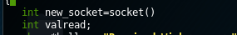

Socket()

Prompt user to input “port number ” to start the listener, and when it successfully listening on the port it state “Listening the port 123 successfully”, assume the user input “123” as port number

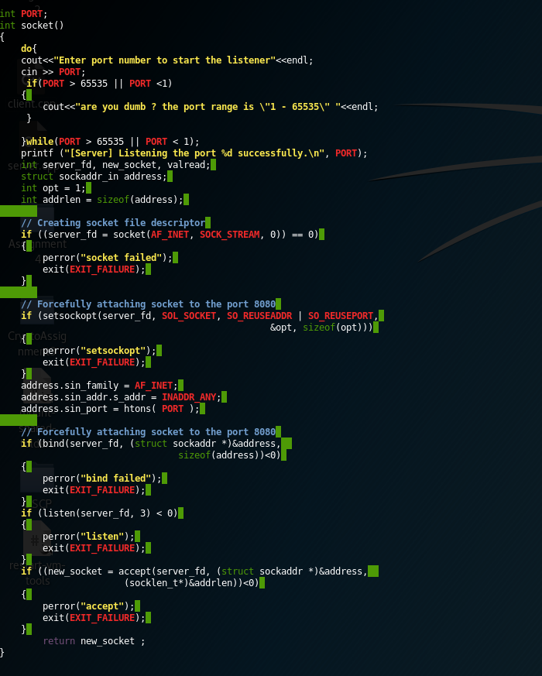

### Output of listening port

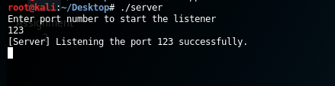

## Execute client – enters the IP and Port number of the Server

From the client’s main()first line of code I declare an int datatype and will grab the value from socket()

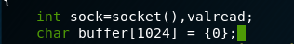

Socket()

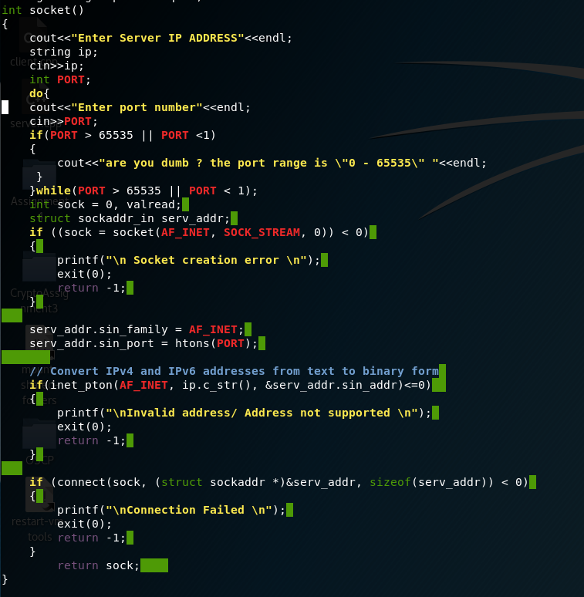

This is the socket function will start to connect to server by asking user to input the “Server IP” and “Server port”. “If connection is establish then it will return sock value” else it state connection failed.

### Output of connecting to server

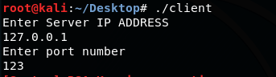

## Client program: starts with generating key pairs; PUA-Public Key and PRA-Private Key using **RSA**

keyGen()

Will perform key generation with rng (1024 bit key) and store into   
“assignment4publickey.txt” and “assignment4privatekey.txt”

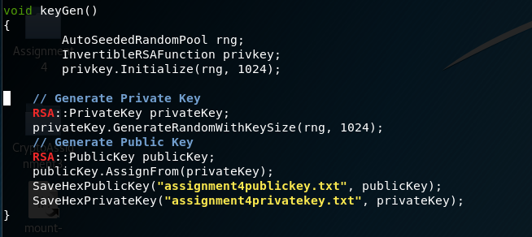

IN HEX format because of following function

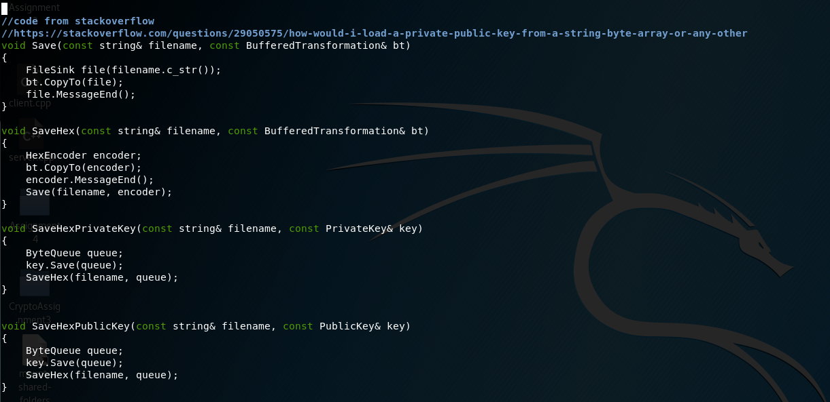

In main() it perform a “display text of RSA Key is generating” then only proceed to keygen() function.

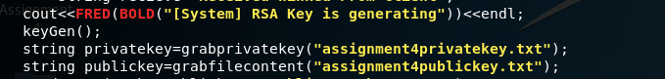

And grab the content from “these 2 following files” and “using 2 different functions” into 2 variable “privatekey” and “publickey”

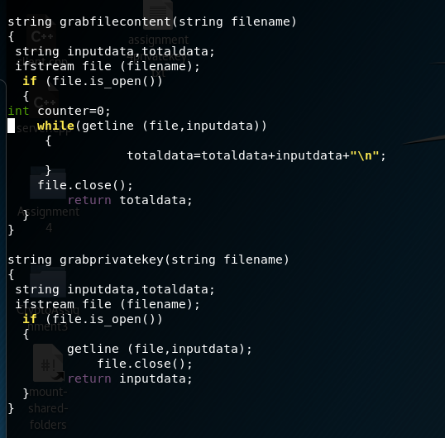

### Output “PublicKey and PrivateKey” File Created

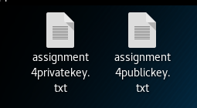

## PUA will be send over to the server, together with the Hash of PUA using **MD-5** for integrity checking. PRA is kept by Client for later Decryption.



First, it will send “publickey variable data” over the network to Server in “plaintext(HEXA FORMAT)”.



After send over the network to Server, it will display the “value of publickey in HEXA format”, and perform a hashing on the “publickey” using MD5 function *image below* and send another data (Digest checksum) to SERVER to verify the “publickey” is not tampered.

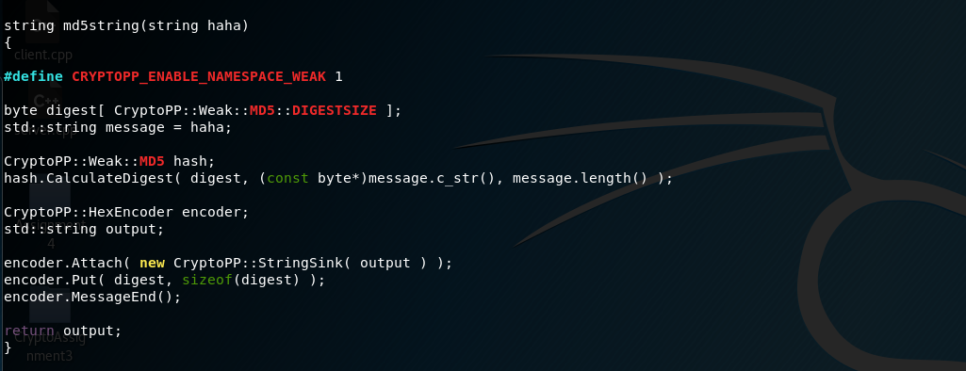

### Output Content of PublicKey and MD5 Digest that send over network

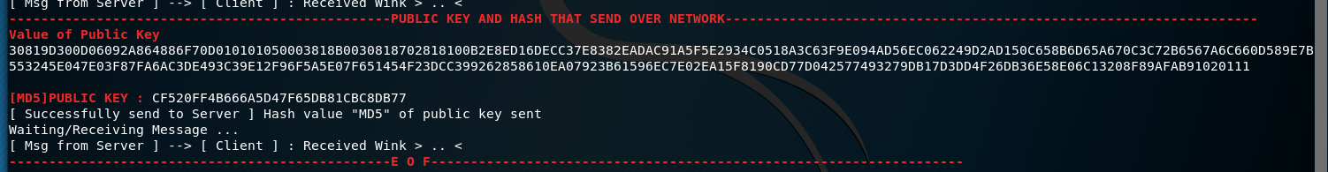

## Upon receiving PUA and H(PUA), Verify them using **MD-5**.

In the server side’s main() function, it will grab the content that send from client into to publickey and hashvalue using *send_recv() function* since **send_recv is returning “string value”**

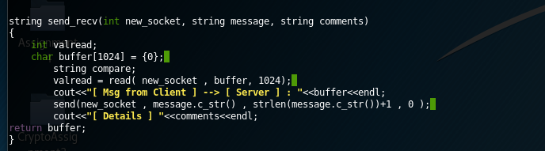

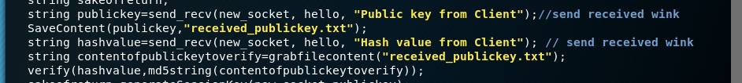

Do notice the second and third parameter, second parameter is just a “variable from server say to client that ‘noted I haved received my message’ and second parameter ‘is just to display’ what kind of content that server is receiving ”.

string publickey=send_recv(new_socket, hello, "Public key from

Client");//send received wink

string hashvalue=send_recv(new_socket, hello, "Hash value from Client");

// send received wink

And according to main() will save the the publickey content into a filename called “received_public.key”

SaveContent(publickey,"received_publickey.txt");

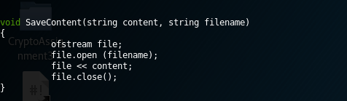

And we have to verify the “publickey” content with “digest” value that sent from client.

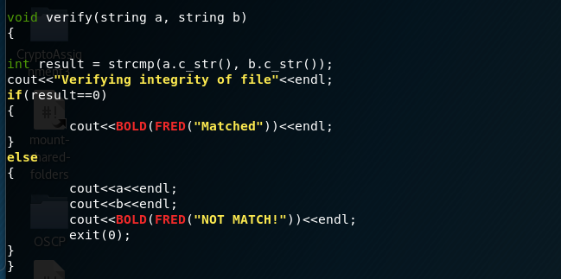

If the values of “PUBLICKEY’s digest” and “DIGEST received from Client” not match then it will “Display not match” and quit the program else it will continue proceed the program.

### Output of integrity checking



## Server generates a session key **Ks1** (**Key size of 8 Bytes)** for the purpose of two keys **3DES encryption**

Complete function ‘string generateSessionKey(int sock,string publickey)’ at section 7

AutoSeededRandomPool prng;

InvertibleRSAFunction parameters;

RSA::PublicKey publicKey(parameters);

parameters.GenerateRandomWithKeySize(prng,1024);

int keys=8;

SecByteBlock key(keys);

prng.GenerateBlock(key, key.size());

//Convert key from bytes to string

string stringKey,temporary;

ArraySource (key, sizeof(key), true, new StringSink(stringKey));

string encodestringKey;

StringSource encodekey(stringKey, true, new HexEncoder(

new StringSink(temporary)));

encodestringKey=temporary.substr(0,16);

cout<<BOLD(FRED("[--------------------------------SESSION KEY IS GENERATING-----------------------------]"))<<endl;

cout<<"EncodedSessionKey Ks1 : "<<encodestringKey<<endl;

.

.

.

StringSource decodekey(publickey,true,new HexDecoder( new StringSink(decodedpubkey)));

StringSource pubKeySS(decodedpubkey,true);

publicKey.Load(pubKeySS);

string encryptedSessionKey;

RSAES_OAEP_SHA_Encryptor e(publicKey);

StringSource encryptboth(encodestringKey, true, new PK_EncryptorFilter(prng,e,(new HexEncoder(new StringSink(encryptedSessionKey)))));

cout<<BOLD(FRED("[--------------------------------SESSION KEY GENERATE COMPLETED-----------------------------]"))<<endl;

cout<<BOLD(FRED("[--------------------------PERFORM ENCRYPTION ON SESSION KEY USING PUBLIC KEY -----------------------------]"))<<endl;

cout<<"[ENCRYPTED]"<<encryptedSessionKey<<endl;

return encryptedSessionKey;

### Output of Ks1 EncodedSessionKey using HexEncoder



## Next, the Server prepares Ks = Ks1 + Ks2 | Ks1 is the 8 bytes key while Ks2 is the **reverse of Ks1**

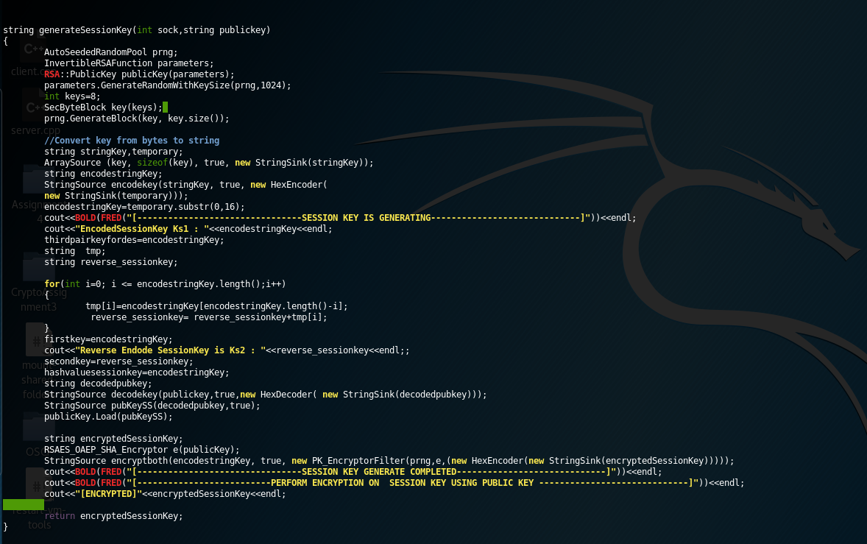

Which will return the encrypted value of “e(Ks1)” which is using publickey to encrypt .

### Output of Ks2 EncodedSessionKey using HexEncoder

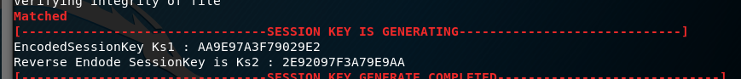

## Server then sends over to Client, encrypted **Ks1** (**8 Bytes**) using PUA that is E(PUA, **Ks1**) and H(**Ks1**)

In main(), it will generateSessionKey and return the **encrypted session key** into variable **“sakeofreturn”** and it will send it over to network using “send_recv()” function and inside the function will display “Server --> Client | Encrypted Session Key” on Server’s terminal

sakeofreturn=generateSessionKey(new_socket,publickey);

send_recv(new_socket, sakeofreturn, "Server --> Client | Encrypted Session Key");

Next it will perform another a MD5 hash on the **“ENCODEDSESSIONKEY”** NOT **ENCRYPTEDSESSIONKEY”** and store into variable **md5sessionencode** send over the network using “send_recv()” function and inside the function will display “Server --> Client | MD5 Session Key” on Server’s terminal

string md5sessionencode=md5string(hashvaluesessionkey);

cout<<BOLD(FRED("[---------------------------------END OF FILE------------------------------------------]\n\n"))<<endl;

cout<<BOLD(FRED("[--------------------------GENERATING HASH VALUE OF ENCRYPTED SESSION KEY FROM CLIENT -----------------------------]"))<<endl;

cout<<FRED(BOLD("MD5 of the PUBLICKEY + SESSION KEY : "));

cout<<"\""<<md5sessionencode<<"\" "<<endl;

sakeofreturn=send_recv(new_socket, md5sessionencode, "Server --> Client | MD5 Session Key");

### Output of ENCRYPTED SESSION and Digest from Server Perspective

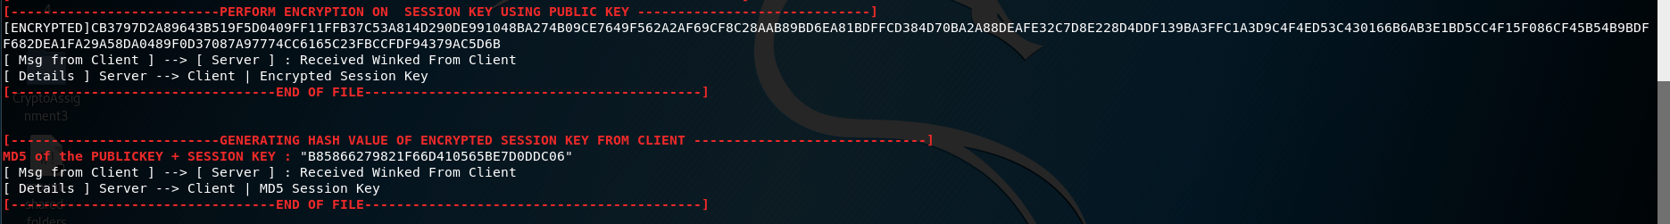

## Upon Receiving of E(PUA, Ks1) and H(Ks1); Client Decrypt the message using PRA , get to know Ks1 (3DES Key size 8 Bytes).

In client’s main()

cout<<FRED(BOLD("------------------------------------------------RECEIVED

ENCRYPTED SESSION USING PUBLIC KEY AND IT HASH VALUE FROM SERVER-------------------------------------------------------------------------"))<<endl;

string encryptedsession=send_recv(sock, recieve, "Encrypted Session Key from Server"); // received encrypted session key from server

send_recv(sock, recieve, "Hash value \"MD5\" of Session Key "); // received hash session key from server

cout<<FRED(BOLD("------------------------------------------------EOF-------------------------------------------------------------------"))<<endl;

After received “*encryptedsession in global variable*” and “*hashencodedsession* *in global variable*” that sent from Server , it will perform decryption on variable “*encryptedsession*” in DecryptSession() function.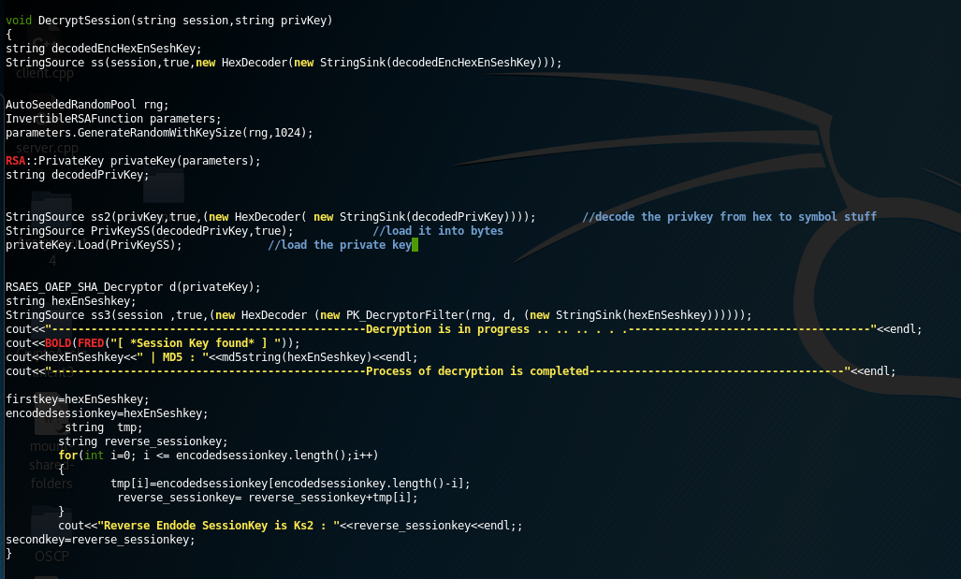

It will use the privKey variable and perform HexDecoder and store into decodedPrivKey and load as privateKey as bytes and use the RSAES_OAEP_SHA_Decryptor load the privateKey and perform “HexDecoder and Decryption using PK_DecryptorFilter” into variable hexEnSeshkey. After finishing the decryption process we generate a checksum MD5 using value that store in “hexEnSeshkey”. So that we can perform the verification processs.

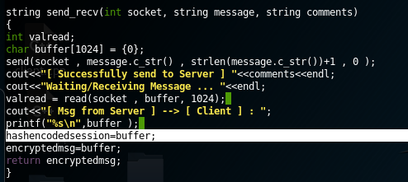

And in send_recv() I do create a variable that store data into hashencodedsession, which mean in previous those publickey that send over the network will also store into hashencodedsession, but when it came to receiving “hash value on encodedsession” I will only use this variable.

### Output Received EncryptedSession in HEX and Digest value from Server at Client terminal’s Perspective and perform decryption process.

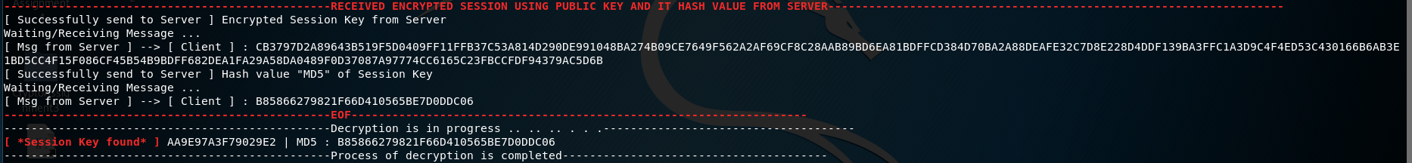

## Then it verifies the integrity of **Ks1** by checking H(**Ks1**) – Hashing via **MD-5**

The value of encodedsessionkey and hashencodedsession is global variable.   
which you can find on section 9 how I generate and assign the value into these variables.

After finished decryption on the encryptedsessionkey.

Now it will go into Verify() to verify both match, whether it matches or not .

*Code in main()*

verify(md5string(encodedsessionkey),hashencodedsession);

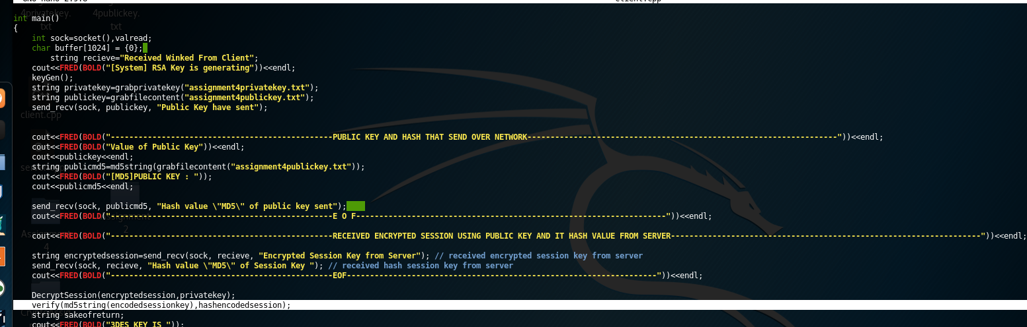

Md5string() function can be found in section 4

Verify()

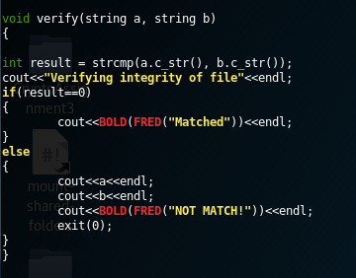

So if the SessionKey’s intergrity is not match it will terminate the program. If the sessionkey’s intergrity is match then it will continue it program.

### Output Verifying intergrity of it files.



## Upon completion of Handshake process above, Client is now use **Ks1** to generate **Ks2** by reversing **Ks1** to produce the complete 3DES Key (**Ks1+ Ks2 = Ks)** to encrypt its data communication

Back to the section 9, which I have already reverse it. It will store at secondkey, and secondkey is a globalvariable.

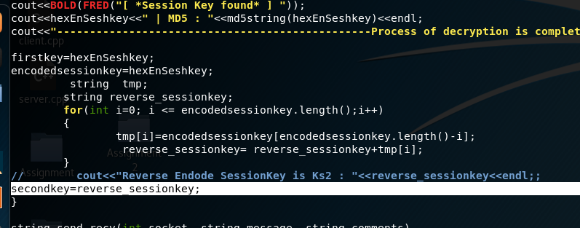

## Client program: Encrypt the message **Mc** using **3DES** encryption with the agreed session **Ks1+ Ks2** (**3DES Key size**)

## Message **Mc** enters **3DES** encryption using **CBC Mode**

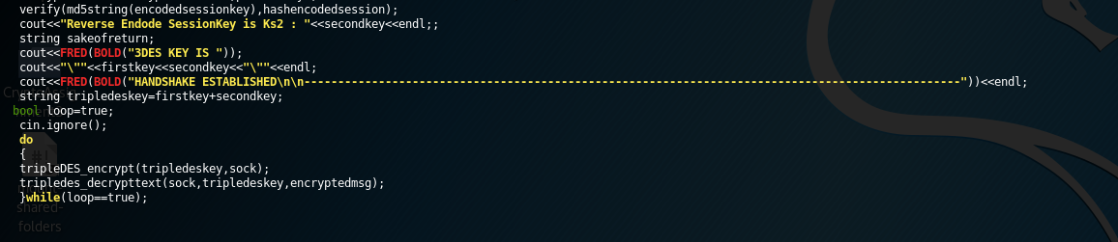

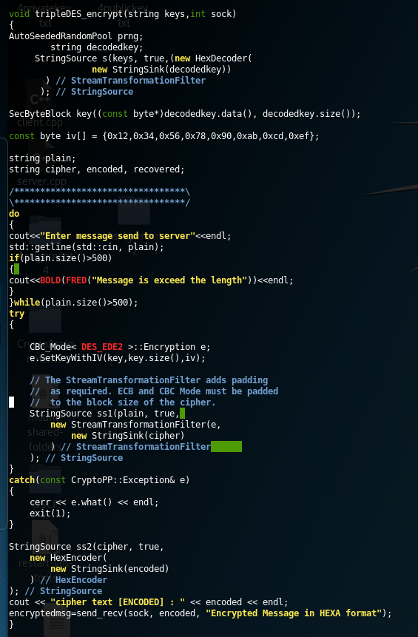It will grab the “firstkey”(global variable) + “secondkey” (global variable) which can be found in section 9 and store combine into a variable called tripledeskey and pass into tripleDES_encrypt() and tripledes_decrypttest() as key to perform the decryption and encryption.

In the encryption process, I have a “hardcoded” iv bytes and uses DES_EDE2 to perform the encryption process.

First the key will perform HexDecoder and store as decodedkey.Next convert the decodedkey into variable key as SecBytesBlock type.

Next will prompt user to input the message to perform encryption and the text length cannot more than 500 length.

Next will create an CBC_MODE DES_EDE2 Encryption object and setkeywithiv and perform encryption process and store the output into variable cipher .

Next use HexEncoder to encode the encryptedtext(cipher) and store as encoded

And use send_recv() function to send over the encrypted message to server. And the “encryptedmessage” that sent from “SERVER” will store in a variable **encryptedmsg** (global variable) so in later we can perform decryption on it

### Output of ReverseEncodedSessionKey and HANDSHAKE ESTABLISH, ready to type message and encrypt it send over network.

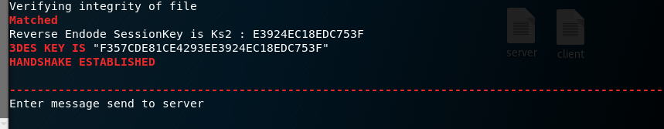

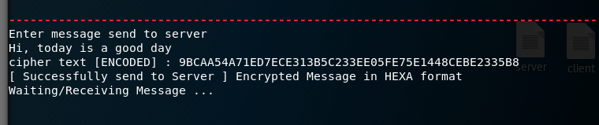

## Server then Decrypt the message **Mc** from client using **Ks1+ Ks2 = Ks**

Back to section 8, after finish sending the “Encrypted SessionKey” and it “hash” to the client.  
It will display the “3DES KEY” and “HANDSHAKE ESTABLISHED”, and receiving message from client.

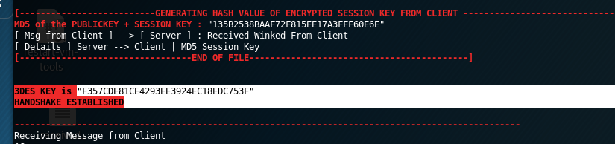

On Server’s main() it will perform a ‘infinite’ loop to keep continuous receive ciphertext and decrypt , and input message and encrypt send over network | same goes to client side but will discuss that in later.

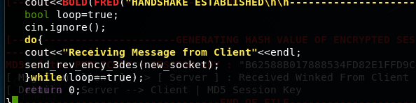

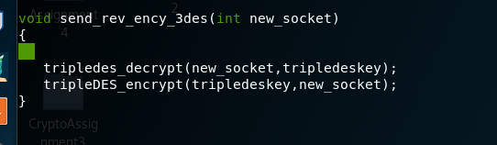

Let take a quick look at the decryption process . 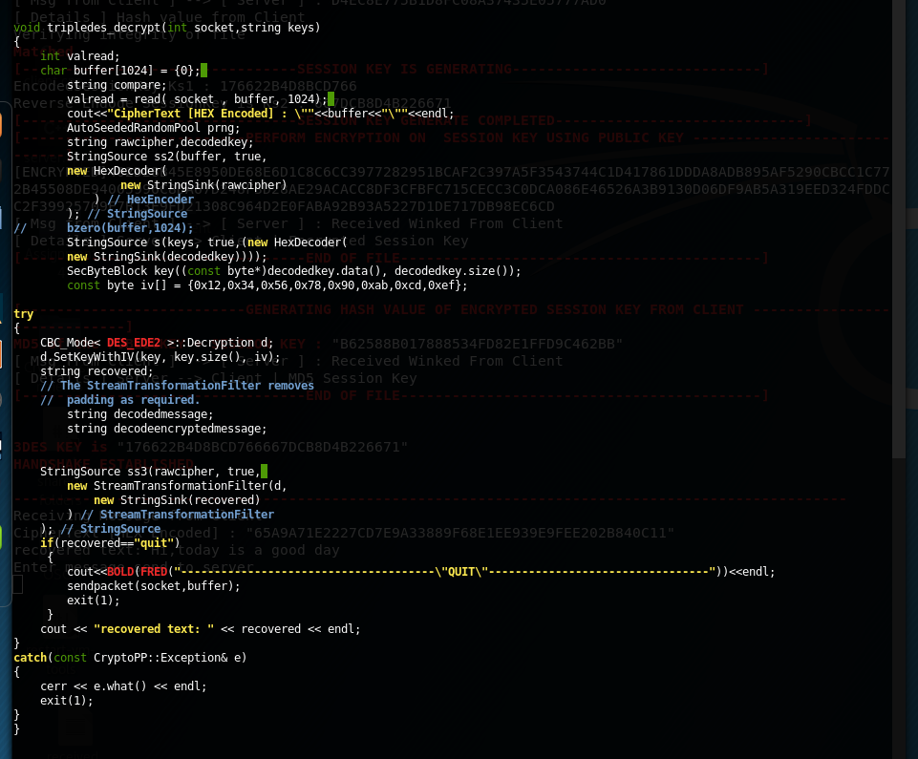

It will grab to receive the message(ciphertext) which encrypt by the client using 3DES algorithm. After recevied the ciphertext it will store into variable “buffer” and perform hexdecoder and store the “raw ciphertext” into variable rawcipher and try to do decryption using the triple3DES(firstkey + secondkey) , if the recovered message is “quit” then the program will quit, if not then will display the “recoveredtext”

### Output of decrypting the message and showing the plaintext

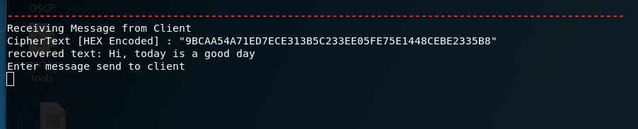

## Server program: Encrypt the message **Ms** using **3DES** encryption with the agreed session **Ks** (**3DES**)

## Message **Ms** enters **3DES** encryption using **CBC Mode**

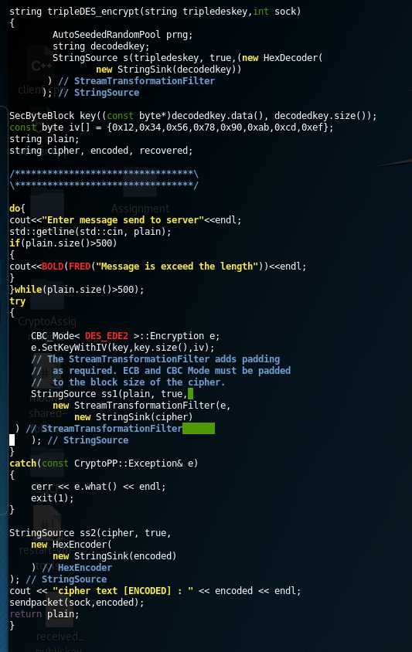On server side’s message encryption, I also uses the same key(firstkey+secondkey 2EDE) decode it using HexDecoder and store the value into decodedkey and convert into key in SecByteBlock data type and the iv in bytes format is const and “fixed”.

Next, server will enter message and the message will (encrypt it and convert it as hex format) and send over the network to client.

If the input message is more than 500 will display message is exceed the length and ask for reinput the message .

Next it will perform encryption therefore we create an object

CBC_MODE<DES_EDE2 >Encryption and setkeywithiv

Next using StringSource ss1(plain, true,

new StreamTransformationFilter(e,

new StringSink(cipher)

and the “cipher” variable now do have a rawcipher and we perform hexencoder and store the value into encoded

StringSource ss2(cipher, true,

new HexEncoder(

new StringSink(encoded)

) // HexEncoder

); // StringSource

Next, after the message is encrypted and convert to Hex using HexEncoder it will send the ciphertext over the network using sendpacket() function.

sendpacket(sock,encoded);

Full code of sendpacket()

void sendpacket(int new_socket,string message)

{

send(new_socket , message.c_str() , strlen(message.c_str())+1 , 0 );

}

This function will send the “encrypted message” over the network and at the client side will able to receive the message.

### Output Enter Message and encrypted it and send over network

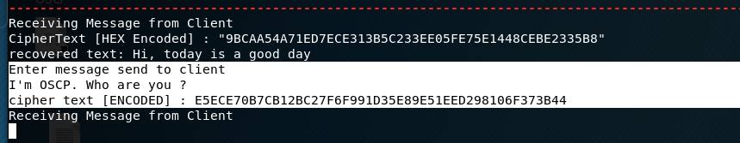

## Upon **receiving** message **Ms** from server, client can decrypt it using the session **Ks**

As I mentioned on section 13 we can see that it’s a infinity loop [Image below]

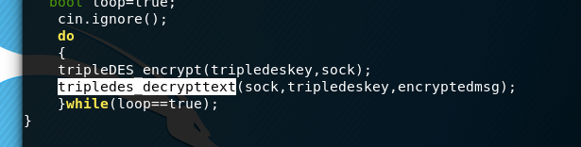

So after finished encrypt the message and send over the encrypted to server and server decrypt it and server send another “encrypted message”.

Now at client side, after received the message from server, it perform decryption and client will perform the input message and encrypt it just like at section 13 and keep looping until either side type the keyword “quit”.

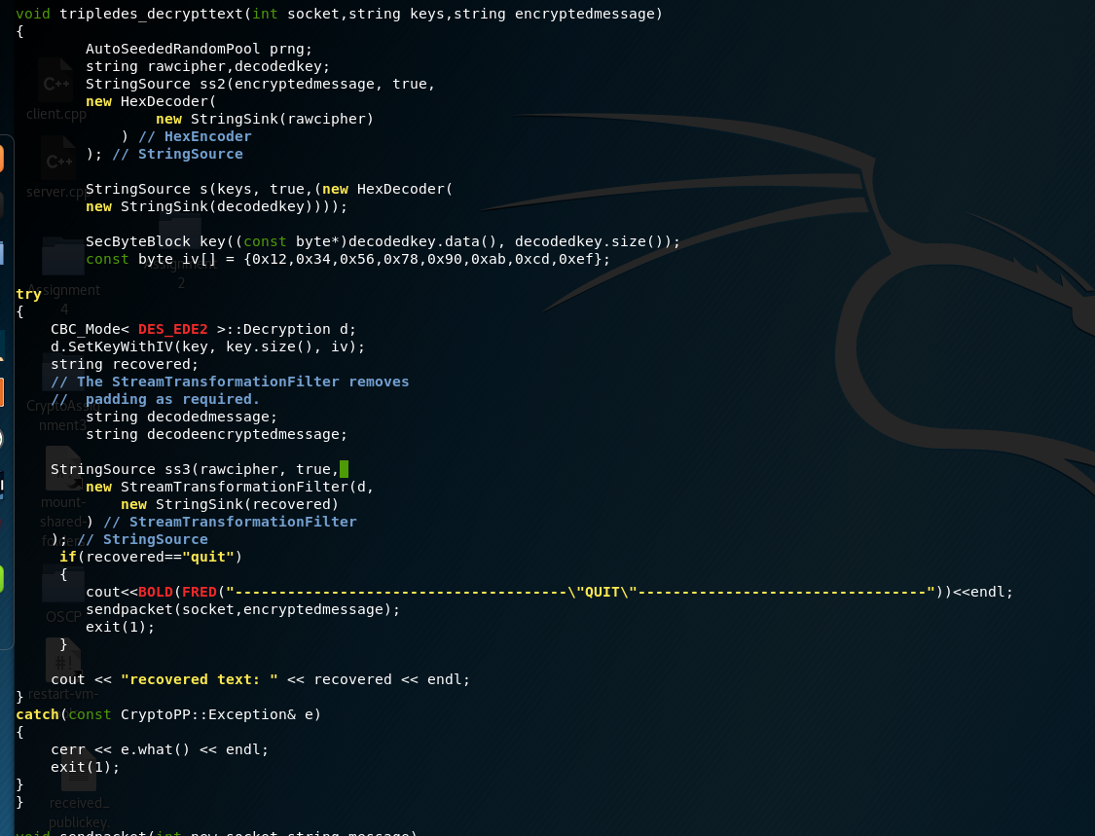so now it will perform decryption process, first it will perform Hexdecode on the ciphertext  
(encryptedmessage) which we can see that the encryptedmessage came from encryptedmsg in main() and the encryptedmsg is came from 3des encryption process which can see in section 13.

So after we have finished the Hexdecoder process on cipher, we decode the key(firstkey+ secondkey) into rawkey and store into variable decodedkey.

Next will convert the decodekey from string to a new variable “key” and it datatype is SecBytesBlock.  
and we create a const bytes iv which is the same value on Server.

Next, will go into the process of tripledes decryption.

Before we go into the process of decryption we have to create a decryption object

CBC_Mode< DES_EDE2 >::Decryption d;

And setkeywithiv

d.SetKeyWithIV(key, key.size(), iv);

Now it will perform decryption

StringSource ss3(rawcipher, true,

new StreamTransformationFilter(d,

new StringSink(recovered)

) // StreamTransformationFilter

); // StringSource

It take the rawcipher and using privatekey which is the object name ‘d’ to perform the decryption and store the value into “recovered variable”.

if the recovered text is “quit” then the program will quit, else then will display the “recoveredtext”.

SERVER CLIENT

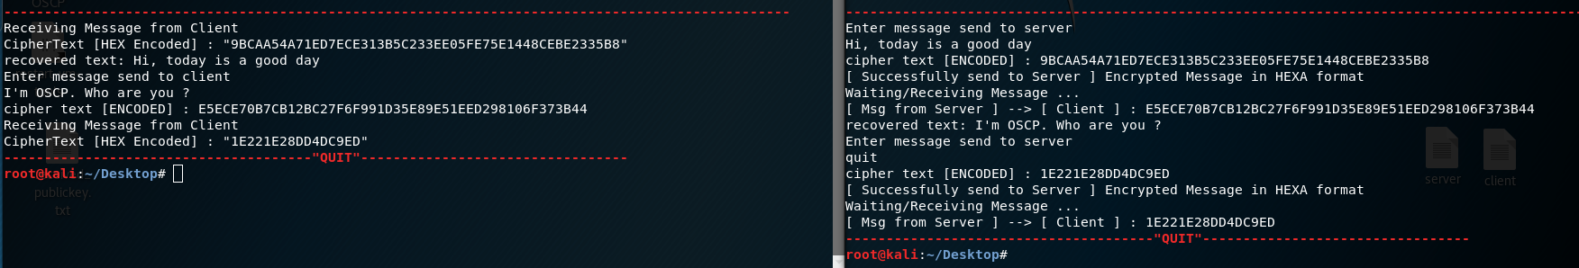

# Output

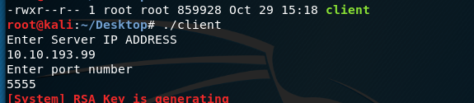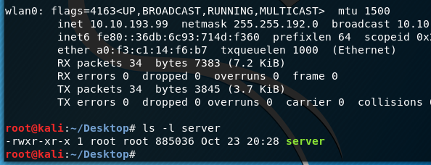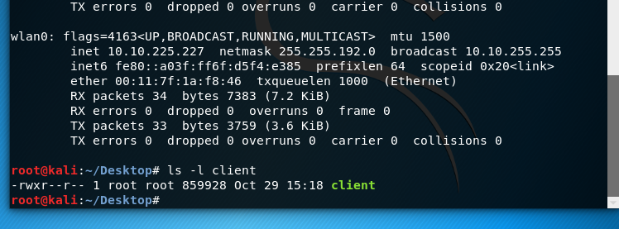Server Client

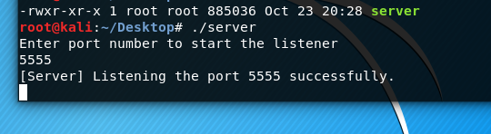

Client 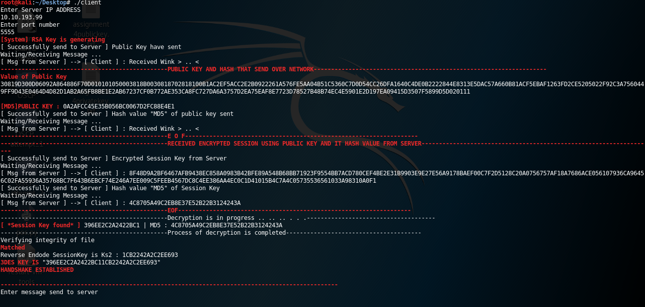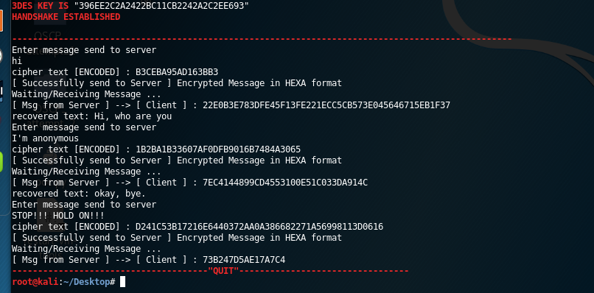

Server

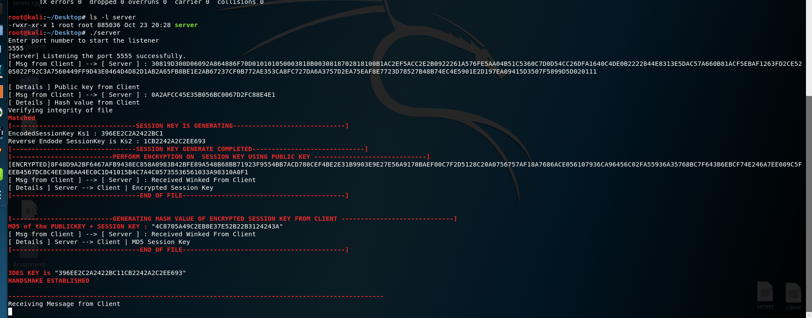

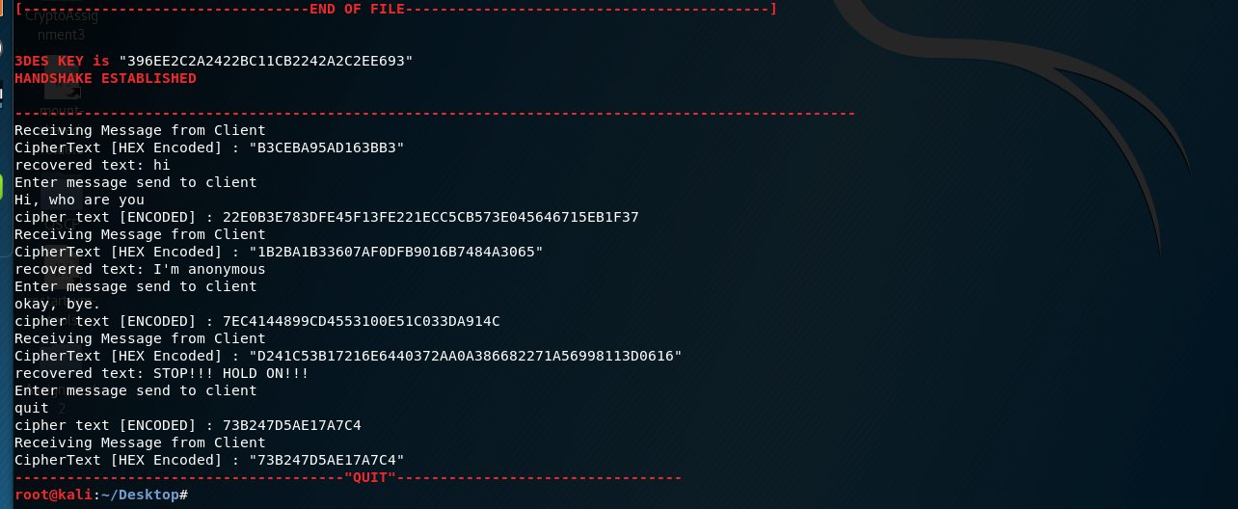

# **USER MANUAL (GITHUB)**

## README.MD

README.MD

## GIT CLONE FROM GITHUB

To download the program in Ubuntu or Linux environment

# git clone https://www.github.com/AppleBois/CryptoAssignment4

Cloning into 'CryptoAssignment4'...

warning: redirecting to https://github.com/AppleBois/CryptoAssignment4.git/

remote: Enumerating objects: 29, done.

remote: Counting objects: 100% (29/29), done.

remote: Compressing objects: 100% (18/18), done.

remote: Total 29 (delta 10), reused 24 (delta 7), pack-reused 0

Unpacking objects: 100% (29/29), done.

## INSTALLATION

Install the crypto++ library or else might not able to build/compile in later.

#sudo apt-get update

Then, issue next command to install crypto++

#sudo apt-get install libcrypto++-dev libcrypto++-doc libcrypto++utils

## COMMAND TO COMPILE/BUILD

How to compile the source code after issued “git clone” command, and will save as seed_cfb using parameter -o

# cd CryptoAssignment4

# cd Source

# g++ -g3 -ggdb -O0 -Wall -Wextra -Wno-unused -o server server.cpp -lcryptopp

#++ -g3 -ggdb -O0 -Wall -Wextra -Wno-unused -o client client.cpp -lcryptopp

## ADD PRIVILEGE TO THE BINARY FILE

Change program privilege to allow execution after issued “git clone” command

# chmod u+x server client

# ls -l

total 1744

-rwxr--r-- 1 root root 859952 Oct 29 19:26 client

-rw-r--r-- 1 root root 12913 Oct 23 18:35 client.cpp

-rwxr--r-- 1 root root 885060 Oct 29 19:26 server

-rw-r--r-- 1 root root 12249 Oct 23 20:28 server.cpp

-rw-r--r-- 1 root root 5855 Oct 29 19:24 Source.7z

# /bin/sh

# ./server

Enter port number to start the listener

^C

# ./client

Enter Server IP ADDRESS

^C

#